Daniel Davieau Unit 8 Homework 6371

Daniel Davieau

March 3, 2018

library(readr)  
Baseball_Data <- read_csv("unit8data/Baseball_Data.csv")

## Parsed with column specification:  
## cols(  
## TEAM = col_character(),  
## Payroll = col_integer(),  
## Wins = col_integer()  
## )

library(ggplot2)  
  
ggplot(Baseball_Data, aes(x = Payroll, y = Wins)) + geom_point()

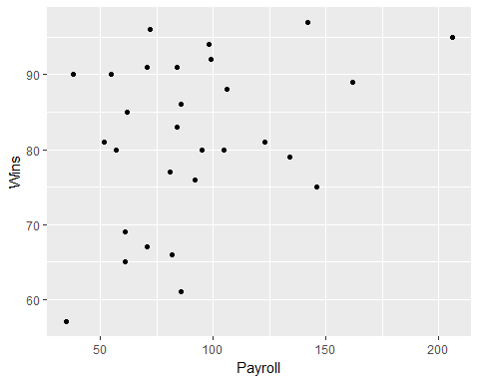

# Add the regression line  
ggplot(Baseball_Data, aes(x = Payroll, y = Wins)) + geom_point() + geom_smooth(method = lm)

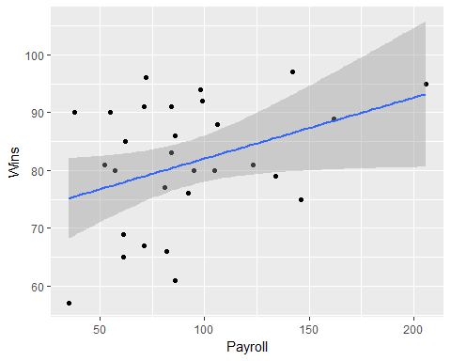

cor(Baseball_Data$Payroll, Baseball_Data$Wins)

## [1] 0.366231

$Zx=15−14.63=.37$ $Zy=81−82.5=−1.5$ $ZxZy=.555$